26.11: Using the same circuit as in Problem 27.10, with all resistances the same:
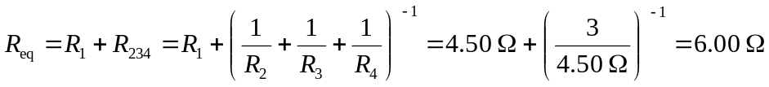.
a) 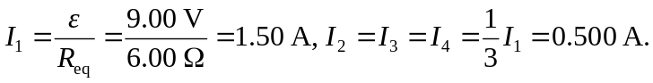
b)
c) If there is a break at 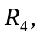 then the equivalent resistance increases:
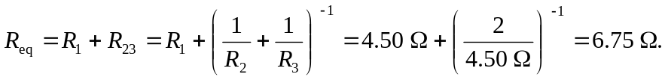
And so:
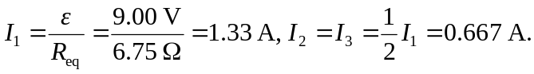
d)
e) So 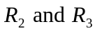 are brighter than before, while  is fainter. The amount of current flow is all that determines the power output of these bulbs since their resistances are equal.

